ABSTRACT

Developing an Intelligent Robotics Course
Oskars J. Rieksts
Jeffrey W. Minton
Kutztown University
rrobe064@live.kutztown.edu
Abstract yet to be written - what is here is the abstract from Bob Roberts paper. *** We report here on a project currently in progress. The project was undertaken to add OpenCV's image processing capabilities to the Myro robotics system. This was done to augment the simple image processing included with Myro.
The environment consists of Python 2.6.4 running on Microsoft Windows XP. The software used is the Python build of OpenCV 2.0 and the SVN build of Myro from November 10th (listed as 2.8.16).
The goal of the project is to provide higher level programming primitives for the Myro user which take advantage of the capabilities provided by OpenCV. This requires the coordination of two otherwise unrelated systems. The next step is to harness the functionality of OpenCV for robotics applications. And, finally, we must abstract the workings behind functions to make the new image processing as easy to use as the old.
At present the first task has been achieved. The second is in progress and the third has not yet been initiated.

KEY WORDS
Robotics, iRobot Create, Image processing, MATLAB

1. Introduction
Today many robotics applications have a significant software component. Not surprisingly it has been recognized by both industry leaders and educators, such as Bill Gates [xxx1], David Touretzky [xxx], and Douglas Blank [xxx3], that a course focusing on the software side of robotics belongs in the undergraduate computer science curriculum. The areas of greatest commonality between robotics and software engineering occur in mobile, autonomous robotics which also require the most decision-making and intelligence of the robot. Thus, ideally, a robotics course in the computer science curriculum would incorporate such features and would be closely allied in subject matter to courses in artificial intelligence. In addition the course should be readily accessible to the average computer science major who has no special preparation in electronics. Thus, the majority of the work expected of students in such courses would focus on software and not on hardware. Finally, both from the standpoint of student interest and for sound pedagogical reasons, the robot should be capable of performing tasks reasonably high on the intelligence scale.
{{for elsewhere in the paper - desired properties of platform such as plug-and-play type of boot up of the robot, good sensor & actuator suite, hardened components, etc.}}
This combination of desiderata, it turns out, is not easy to achieve at a cost accessible to the small to medium sized university budget. For the past five years the first author has offered aspects of robot programming in a special topics course and within artificial intelligence courses. The most recent effort was a special topics course in Intelligent Robotics, funded in large part by grants from the PASSHE Faculty Professional Development Committee and Tyco Electronic Foundation, which formed the basis for proposing an intelligent robotics course as a permanent part of the computer science curriculum. We report here on the development of that course and on the design of the proposed course.

2. Early Experience
In retrospect, it is clear that the initial stages were comprised of traversing a learning curve. There were a number of successful projects completed, but they were not replicable. In some cases they were one-of-a-kind projects requiring significant individual effort which could not be translated into class projects. For example, one student produced a Mindstorms-based Rubik's Cube solver. Another wrote an API for the hacked Roomba vacuum cleaner from iRobot. And a team of students placed Arduino controllers into remote control cars to make them autonomous and programmable.
A significant portion of early work was devoted to testing - and ultimately rejecting - a number of hardware platforms because they did not allow us to meet the goal described above. The earliest platform was the Roomba with various approaches to hacking it and producing robotic programs. This was soon obviated with the advent of the iRobot Create. Although a step in the right direction, the Create by itself did not meet our criteria. The iRobot controller did not have sufficient memory for significant programming, using an off-board computer as controller ran afoul of communication problems, and the sensor and effector suites did not afford the opportunities for intelligent programming we sought.
At about the same time we also experimented with the Lego Mindstorms kits. We found the drag-and-drop programming interface too cumbersome for writing complex programs. Writing programs in Java using the Lejos operating system was an improvement, but suffered from limited memory. Building robots using Lego bricks had its own set of problems. The process was time-consuming with no relevance to computer science as a discipline. And the constructions were unstable. Seeking to increase functionality by adding sensor or actuators became an expensive time-consuming and risky exercise in shopping.
The Vex robot kit appeared to offer a viable alternative to the Mindstorms approach. Construction material was more stable and programming was in a dialect of C++. Upon closer look, however, significant problems became evident. . . . sensor, effector limitations, configuration limitations, lack of portability of software from machine to machine . . .
At this point it was clear that there was significant student interest in robotics. In addition the success of the DARPA Grand Challenge, the growth of the robotics industry and widespread interest in its continued development, as evidenced by the Congressional Robotics Caucus, all provided impetus to keep searching for the right approach. During this time frame the second author built a robot to enter the Trinity Robot Firefighting Contest. With funds from the Kutztown University Undergraduate Research Committee, augmented by funds from the Tyco grant, he rebuilt the chasis from a Vex robot kit to hold an EEE netbook computer, an Arduino microcontroller chip and a XXX camera. [... Jeff - can you add more here? ...]
Early in the spring of 2010 major commitment was made to the Myro robotic system developed by Georgia Tech and Bryn Mawr College. These robots consisted of the Scribbler robot as chasis and the Myro Fluke providing programming capability via Python and the basics of image processing as part of the Myro package. Five copies were purchased with grant funds and distributed to teams in an artificial intelligence class. In fairness to the developers of Myro, it must be pointed out that target audience of its developers was the CS1 class [xxx7]. It turned out that the hardware, even with the supplied software interface, was unable to provide the basis for the kinds of projects one would want in an A.I. course. The drive motors for the wheels were too iffy to allow a program to set a course and expect to achieve it. The image from the camera on the Fluke was of insufficient quality to provide the basis for , etc. etc.
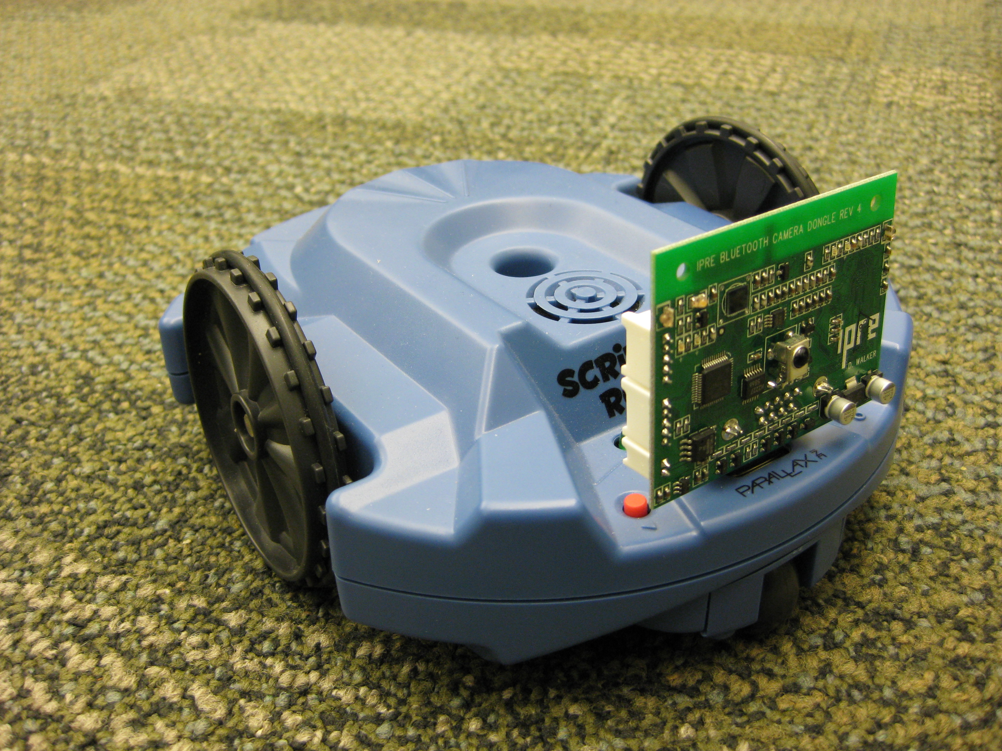
Figure 1: The Scribbler and Fluke [3]

3. Hardware and Software Configuration
Late in the spring of 2010 the first author received an SSHE Faculty Professional Development grant to develop an intelligent robotics course. The second author, a graduate student, worked with him on this project during the summer and fall of 2010. The hardware and software design was a collaborative effort, with the second author taking the lead on hardware.
The goal for the configuration was a hardware and software platform which afforded the opportunity for significant intelligence in control and decision-making. In addition, we wanted the configuration to have an open-ended quality which would allow the course content to grow, with time, in complexity and challenge. In particular, a major goal for us was to aim for communication and collaboration between robot and human. This was inspired by the success of Kantrol {Sp} [xxx . .] and other similar systems, but also by the clear need for robot-human communication for any viable robotic wheelchair system. This pushed us toward continuing with the use of a camera as a major source of information about the environment. Our collective experience gave us a predilection to using the design of the fire fighting robot as a starting point and making appropriate adjustments.
In addition to taking advantage of previous experience (and striving to overcome the shortfalls of previous systems), the authors drew upon the significant experience of John Spletzer [xxx ..] of Lehigh University and consulted also with John Grenzer, Vice President for Technology of The Good Shepherd Rehabilitation Hospital. Spletzer teaches a robotics course in the Computer Science Department at Lehigh, was a team leader for the Little Ben entry in the DARPA Urban Challenge [xxx ..], and is lead developer of a self-stowing robotic wheelchair [xxx . .]
Since the department already had several iRobot Creates, to keep costs down it made sense to use them as the basis and to use an onboard computer for the control software. This was similar to the setup Spletzer used for his robotics course and in conversations we were assured that it was a viable platform. The onboard computer was to be an EEE {xxx etc.}, but as we wanted a camera with a wider view we chose the Microsoft LifeCam {xxx etc.}. As in the fire fighting robot an Arduino microcontroller gave us the flexibility of adding sensors, though at this point the only sensor we have added is the {xxx} IR rangefinder.
In terms of software, the initial plan was to run Ubuntu Linux with Python as the main programming language and to use OpenCV [xxx . .]for image processing. It soon became clear that OpenCV did not provide a an entry point at a sufficiently low level for the average computer science major. John Spletzer uses MATLAB for much of his robotic work. He recommended that software package to us and offered us the use of a Create API written in MATLAB. Using FPDC grant funds we purchased a classroom license of 10 copies of MATLAB. Five copies were loaded on the netbooks to control the robots, four were put in a computer lab for students use and one was allocated to the course instructor for class preparation. The choice of MATLAB also dictated that we use Windows as our operating system. Right before the start of the semester we made the switch. At this time, too the University Carpenter Shop built a platform to house the netbook, the camera and the microcontroller. We had sufficient funds in the FPDC grant for 4 complete systems. Using the netbook from the fire fighting robot we had a 5th system for the graduate assistant. Figure 1 shows the completed configuration.

4. The Robotics Course
This section will be about design and implementation of the course.

5. PACT Demonstration
This section will describe the experiences of the PACT demo.

6. Image-guided control
This section will be about the use of image processing to guide the robot.

6.1. Acquisition and interpretation of image data
Getting the info, processing & storing it.

Figure 2: Test picture with multiple circles on textured background

6.2. Ontology-based world knowledge
How the world info would be stored

6.3. Blackboard implemented behavior based control
The set of behaviors and their implementation in a blackboard task scheduling system.

7. Robot-Human Communication
This section will be about the use of image processing to guide the robot.

7.1. Communication Theory
What is communication, how it is to take place, etc.

7.2. Semantic Parsing
Theory and examples

7.3. Establishing co-referents
How image processing & semantics are combined to give robot and human common points and objects of reference in the shared environment.

7. Assessment
What we learned and recommendations, including outline of proposed Intel. Rob. course, CSC445.

8. Future Work
Where this course may go in the future

9. References
[x1] Touretzky, David S. Preparing Computer Science Students for the Robotics Revolution. Communications of the ACM (CACM), 53(8):27-29, August, 2010.

[x2] Gates, B. A robot in every home. Scientific American
(Jan. 2007), 58–65, January 2007.

[x1] Blank, Douglas. Robots Make Computer Science Personal. Communications of the ACM (CACM), 49(12):25-27, December, 2006.

[x3] Gonzalez, Rafael C, Woods, Richard E. and Eddins, Steven L. Digital Image Processing Using MATLAB, 2nd Ed. Knoxville, TN: Gatesmark Publishing (2009).

[x4 Bradski, Gary and Kaehler, Adrian. Learning OpenCV: Computer Vision with the OpenCV Library. Sebastopol, CA: O'Reilly Media (2008).

[x5 Wahlster, Wolfgang (ed.). SmartKom: Foundations of Multimodal Dialogue Systems. New York: Springer Verlag (2006).

[6]Feature Detection — OpenCV 2.0 C++ Reference. (n.d.). Retrieved February 9, 2010, from http://opencv.willowgarage.com/documentation/cpp/feature_detection.html#houghcircles

Deleted material - some of this may need to be put back in somewhere:
Also notes . . .
The basic robotic unit consists of a Create robot with an EEE netbook, a Microsoft Lifecam and an Arduino microcontroller riding on the Create on a platform designed and built by the University's Carpenter Shop, as shown in Figure 1. The purpose of adding the Arduino is to permit the addition of sensors to give the robot greater operational flexibility. For example, since the Create does not have viable distance sensors, an infrared (IR) sensor was added, with the data from this sensor being passed through the microcontroller to the onboard computer.

Notes:
Harnad's symbol grounding problem
Beer's SED framework

